Curriculum Vitae
Name : Dr. Gajanan Laxman Gulhane 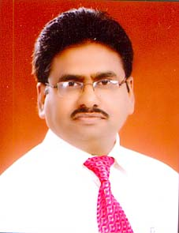
Education : Ph.D.(Education).,M.Ed., M.Sc.(Maths)., DIT

Present Position : a) Head, Post Graduate Department of Education,
Sant Gadge Baba Amravati University, Amravati

b) Director, Dr. Shrikant Jichkar Memorial Research Centre,
Sant Gadge Baba Amravati University, Amravati (Additional Charge).

c) Chairman, Board of Studies in Education,
Sant Gadge Baba Amravati University, Amravati

d) In-charge Member, University Skill Development, Employment &
Entrepreneurship, Information & Guidance Bureau, Sant Gadge
Baba Amravati University, Amravati (Additional Charge).

Permanent Address : Medha Apartment, ZP Road,
Opposite I. G. Bungalow, CAMP.
AMRAVATI - 444 602, Maharashtra, India
e-mail: glgulhane@gmail.com
Mobile No. 09527360926; 0721-2666502

Total Teaching Experience : Total 28 years including Post Graduate, Under Graduate and
Junior College Level.

Research Experience : 16 Years (After Ph.D.)
Ph.D. Degree awarded = 14 Scholars
Ph.D. working = 04 Scholars
M.Phil. Degree awarded = 11 Scholars

Research Guide : Ph.D. and M.Phil
a) Sant Gadge Baba Amravati University, Amravati.
b) Gondwana University, Gadchiroli
c) Acharya Nagarjuna University, CDE, Nagarjuna Nagar, AP

Research Publications : Total 40 Research Papers published in National & International Level Journals

Book Publication: 05 Books – a) Educational Researches (2010)
b) Learning Disability (2012)
c) Research and Statistics (2013)
d) Childhood and Growing Up (2015)
e) Educational Philosophy of Rashtrasant Tukdoji Maharaj (2016 )

Conference / Seminars : Participated and presented research paper in (76 nos.)
- International Conference ………………………10
- National Conference …………………………...30
- State Level Conference…………… …………..12
- University / Divisional Level Conference ……. 24

Country Visited : Malaysia for presenting research paper in June 2013.

Research Project Completed : 03
- “Educational Problems of Tribal Students at Primary Schools in Melghat Area of Maharashtra”.
Financed by U.G.C. New Delhi.(2009)
- “Dr Babasaheb Ambedkar’s Vision on Educational Development of the Schedule Caste Children: A Study in the Slum Areas of Amravati City”. Financed by U.G.C. New Delhi.(2010)
- “Sensory and Mobility Disabilities in Primary School Students and their Academic Achievement: A Study in Amravati Division of Maharashtra” Financed by ICSSR, New Delhi. (2014).

On line Videos: I have uploaded 25 Videos (Teaching skills + Research) on the website of SWAYAM and
YouTube in 2018 for UG and PG teachers.

Area of Specialization : Informal, Special & Teacher Education
Editor: ‘Review of Research’ Proceeding of National Conference on Policies and Prospects of Teacher
Education-2019.
Coordinator of Refresher Course: Coordinator of Refresher Course in Education and Physical Education
held during 28.05.2009 to 14.06.2009 at UGC-Academic Staff College, SGB Amravati University,
Amravati.
Participation in Academic Works Assigned by the University:
- Chairman of Furniture Purchase Committee
- Worked as member of University Purchase Committee
- Member of Grievance Redress Cell for Sexual Harassment Committee - Code of Conduct
- Member of Board of Studies (BOS).
- Member of Board of University Teaching & Research (BUTR)
- VC Nominee and Subject experts in selection of University Teachers
- Placement Officer of Dept. of Education.
- Worked as member of Examination Equivalence Committee.
- Worked as member of Research Recognition Committee (RRC) SGB Amravati University
- Worked as member of Research Recognition Committee (RRC), YCMO University, Nasik;
RTM Nagpur University, Nagpur; and North Maharashtra University, Jalgaon.
- Experience of Conducting Inspection of Teacher Education Institutions on Behalf of NCTE University: Three times
Curriculum Revision of Education:
a) Worked as Coordinator of “Revision of B.Ed., M.Ed., & M.Phil. Curriculum 2009-10"
and Academic Council of Sant Gadge Baba Amravati University, accepted revised
Curriculum and issued Notification on 19.03.2009.

b) Member of Advisory Committee of Curriculum Framework-M.Ed., Yashwantrao Chavan
Maharashtra Open University, Nashik, Maharashtra

Awards: 1) Dr Anand Waskar Utkrushta Granth Puraskar to the book “Research and Statistics”
in Jan. 2014.
2) Utkrust Seva Gaourav Puraskar (Best Teacher) 2014 honored by Hon’ble Vice Chancellor,
Sant Gadge Baba Amravati University, Amravati on 1st May 2014.

Invited Talks Delivered : In Conference, Workshop, and Seminar = 20 times
Resource Person : In UGC Sponsored Orientation and Refresher Course = 60 times
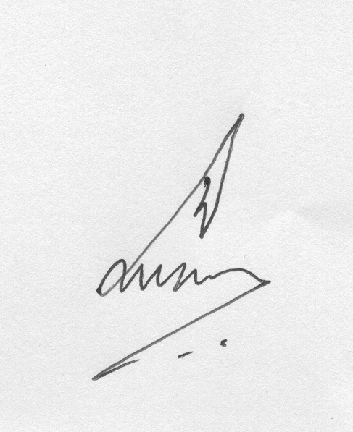 Place : Amravati ( G.L.Gulhane)
Date : 20.09.2019

